Create an Ubuntu VM on AWS and install Apache, ending with testing the default Apache landing page.
This works on AWS Free Tier / lowest cost.
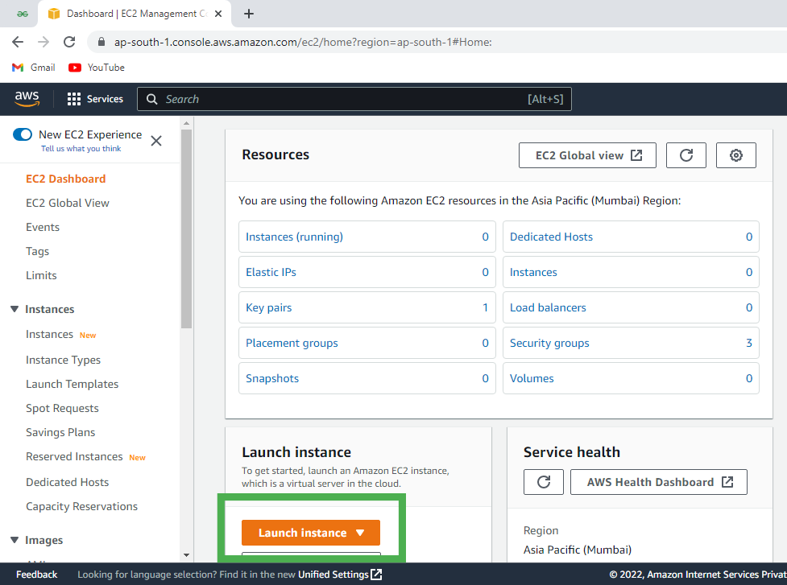
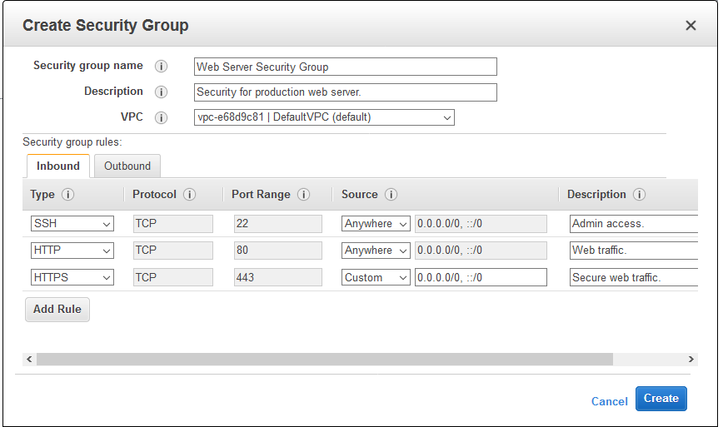
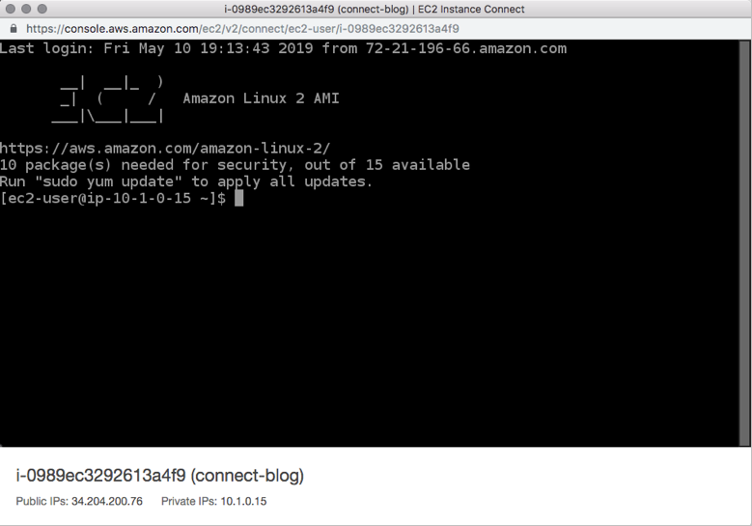
4

1️⃣ Sign in to AWS
- Go to AWS Management Console
- Sign in with your AWS account
- At the top-right, select a Region
👉 Cheapest & safest: US East (N. Virginia)

2️⃣ Launch an Ubuntu EC2 instance
AWS Console → Services → EC2 → Instances → Launch instance
Step A — Name & OS
- Name: ubuntu-apache-lab
- AMI: Ubuntu Server 22.04 LTS (64-bit x86)
(Provided by Canonical, Free Tier eligible)
Step B — Instance type
- t2.micro (Free Tier)
or t3.micro (very cheap, faster)
Step C — Key pair (SSH access)
- Click Create new key pair
- Name: aws-ubuntu-key
- Type: RSA
- Format: .pem
- Download and keep it safe
Step D — Network settings (IMPORTANT)
Click Edit
Security Group → Inbound rules:
Type | Protocol | Port | Source
SSH | TCP | 22 | My IP
HTTP | TCP | 80 | Anywhere (0.0.0.0/0)
⚠️ HTTP (80) must be allowed or Apache will not load.
Step E — Storage
- 8 GB (default) – keep as is
Click Launch instance

3️⃣ Connect to the Ubuntu VM (SSH)
Wait until instance status = Running
EC2 → Instances → select your instance → Connect
Option A — Browser (easiest)
- Choose EC2 Instance Connect
- Click Connect
Option B — From your own terminal (PowerShell / WSL / macOS)
chmod 400 aws-ubuntu-key.pem
ssh -i aws-ubuntu-key.pem ubuntu@<PUBLIC-IP>

4️⃣ Update Ubuntu
Inside the VM:
sudo apt update
sudo apt upgrade -y

5️⃣ Install Apache Web Server
sudo apt install apache2 -y
Start & enable Apache:
sudo systemctl start apache2
sudo systemctl enable apache2
Check status:
systemctl status apache2
You should see active (running).

6️⃣ Test Apache default landing page 🎉
Step A — Get Public IP
EC2 Console → Instance → copy Public IPv4 address
Step B — Open browser
http://<PUBLIC-IP>
✅ You should see:
“Apache2 Ubuntu Default Page”
That confirms:
- EC2 VM is running
- Apache is installed
- Security Group allows HTTP

7️⃣ (Optional) Verify Apache files
Default web root:
ls /var/www/html
Default page file:
cat /var/www/html/index.html

8️⃣ (Optional) Replace default page
sudo nano /var/www/html/index.html
Example:
<h1>Hello from AWS Ubuntu Apache</h1>
<p>Student lab successful.</p>
Save → refresh browser.

9️⃣ Cost control (VERY IMPORTANT for students)
When finished:
EC2 → Instance → Stop
✅ Status must show Stopped (not Running)
💸 Stopping saves most charges

🧠 What you have learned (lab-ready)
- Launching an Ubuntu VM on AWS
- Configuring security groups
- Installing & managing Apache
- Verifying web services via browser

